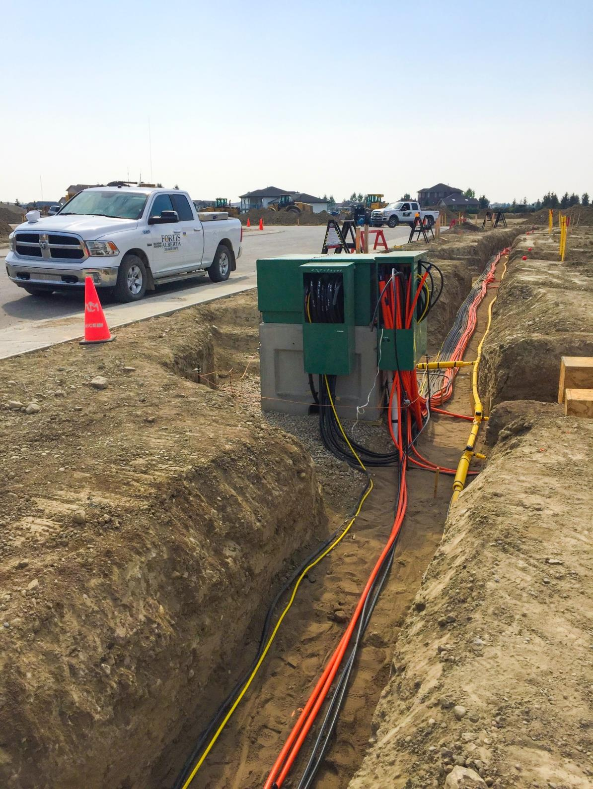


customer installed pre-cast base, grounding, and ducting
Version No: 5.5
September 24, 2025
Copyright © 2025 FortisAlberta. All rights reserved. No modifications or reproductions are allowed without written permission.
Printed on Oct. 1, 2025 at 1:46 PM. The current revision is on FortisAlberta Standards Database.

Table of Contents
1. Scope and Purpose 3
2. Service Classifications 3
3. Pre-Registered Design Consultants and Construction Contractors 4
4. Glossary 4
5. CIPGD Process Steps 4
6. General Requirements 7
7. Design & Installation Guidelines 9
8. Material Standards and Specification 15
9. Inspection and Testing 17
Annex A Revision History (Informative) 18
Annex B Forms and Reference (Informative) 20
Annex C Duct Systems (Informative) 46
Annex D Conduits (Normative) 51
Annex E Grounding Materials (Normative) 52

Significant content changes since the last revision (Revision 5.4, December 19, 2024) are shown in purple for convenience.

Scope and Purpose

The Customer Installed Pre-Cast Base, Grounding, and Ducting (CIPGD) Process offers the ability for customers to install the pre-cast base, grounding, and ducting, specific to the customer’s electric service requirements, within their development. This will allow the customer to manage the proper installation of pre-cast base, grounding, and ducting within their control. However, the CIPGD process should be followed diligently for the efficient installation of these facilities.

The Customer Installed Pre-Cast Base, Grounding, and Ducting (CIPGD) Process is applicable to single property developments (i.e., general service/commercial, industrial, oil & gas, commercial complex, malls, bare land commercial developments, apartment buildings, recreational vehicle parks, etc.) with one or multiple electric service requirements.

The CIPGD process covers FortisAlberta’s general requirements for the design and installation of underground electrical distribution system facilities on customer property. This includes cable ducts, transformer bases, grounding, etc. These facilities are to be installed by the customer and are to be inspected and accepted by FortisAlberta. FortisAlberta will proceed to install the primary cables and transformer for the customer. These facilities will be energized and maintained by FortisAlberta.

Multiple property developments (i.e., Commercial, and Industrial subdivisions) are excluded in this CIPGD process.

The design and installation of Underground Electrical Distribution Systems (UEDS) on residential developments and bare land developments are excluded in this process and shall follow the requirements provided in FortisAlberta’s UEDS manuals.

All requirements related to metering are not part of this document. Please refer to the FortisAlberta Service & Metering Guide (SMG) on www.FortisAlberta.com. This document is meant to complement the FortisAlberta’s Service and Metering Guide and in no way overrides it.

Farm, Irrigation, and Rural Residential services are excluded in this process. FortisAlberta will install the underground electrical distribution systems on Farm, Irrigation, and Rural Residential services.

Service Classifications

Simple Services - services are classified as Simple Services when all the following apply:
- One pad-mounted transformer is servicing one site.
- Length of duct is less than 150 m and has combined deflections (sweep or bend) less than 90° (excluding the bend inside the transformer pad).
- There are no crossings and/or proximities with other facilities that require approvals (pipeline crossings, etc.).
- Lot is up to final grade (± 150 mm).

Complex Services - all services that do not satisfy the Simple Services requirements above.

Pre-Registered Design Consultants and Construction Contractors

Use of Pre-registered Design Consultants and Construction Contractors
The Pre-cast Vendor list is available in the www.FortisAlberta.com website under the For Business and Industry / Construction link.
The use of design consultants is mandatory for designing Complex Services. For Simple Services, the use of design consultant is optional.
The construction and installation of pre-cast base, grounding, and ducting in the CIPGD process shall only be performed by the construction contractors listed on the FortisAlberta pre-registered list.

Pre-registration Process
FortisAlberta’s pre-registration process is required for companies to do work for FortisAlberta.
Design consultants and construction contractors who want to obtain more information on our pre-registration process or who want to be listed to be able to do work for FortisAlberta can apply to our Contract Services group through e-mail contracts@FortisAlberta.com or by fax at (403) 514-5981.

Glossary
AFC: Customer Approved For Construction drawing.
BOM: Bill of Material
Duct/conduit: Terms used interchangeably for plastic, metal or PVC tubing used to encase underground conductor.
Offsite work: The work required outside of the customer’s property to get the customer’s electric service connected to FortisAlberta’s electric distribution system. FortisAlberta will complete the offsite work.
Red-line Records of all construction deviations from AFC drawing.
Record drawing: Authenticated drawing created to record design changes for which the professional member has accepted responsibility.
SMG: FortisAlberta Service & Metering Guide
Transformer or cubicle base/pad: Terms used interchangeably for pre-cast concrete bases used to mount a switching cubicle or padmount transformer or MVI.
UEDS: Underground Electrical Distribution System

CIPGD Process Steps
The CIPGD Process is provided in detail below. The customer is responsible to follow the CIPGD process.
All work associated with fixing deficiencies in customer installations, such as exposing of already installed customer facilities due to improper installation and premature backfilling, is to be completed by the customer at their expense. As such, compliance to the CIPGD process is needed.
A flow chart outlining the CIPGD process can be found in Annex B, Item 13.

Initial Contact
Customer calls 310-WIRE (9473) or fills out an online new customer service connections application form to request a new power service or a change to an existing service. The online application form for all service types can be found under “Get Connected” on www.FortisAlberta.com.

New Service Quote
The customer submits a copy of the most recent site plan showing all utilities, buildings, transformer locations, ducting route (include burial depth), existing/proposed above and underground facilities, deep (water/sewer) services, dimensions of the property site and buildings, customer construction schedule and required connect date.
A site meeting with a FortisAlberta representative may take place as required. The scope of work for the new service is estimated by FortisAlberta and a quote letter package is sent out to the customer.

Customer Acceptance
The customer reviews quote, approves, and makes payment, as required.

Design: Preliminary Review/Meeting
FortisAlberta contacts the customer and determines the type and location of any offsite work or facilities that FortisAlberta must perform or provide.
Preliminary design drawings and details are reviewed with the customer and/or pre-registered design consultant. FortisAlberta determines which category the new service will fall under: Simple or Complex Service.
FortisAlberta provides the customer and/or pre-registered design consultant with FortisAlberta minimum design standards and any other details the customer may need, to follow design standards and safe construction practice.
The customer and/or pre-registered design consultant supplies Approved for Construction (AFC) drawings as soon as practical after review/meeting. The AFC drawings must show details of the transformer base, grounding, guard posts (bollards), location of pads relevant to buildings, proposed final grades along the duct alignment and at all transformers/equipment, driving services, and other above and underground facilities. All drawings should be marked as AFC.
The customer also supplies construction schedule and required connection date.
Installation of ducting, transformer pad and grounding must not begin until AFC drawings have been accepted by FortisAlberta.

Applicable only for Complex Services:
Cable pulling calculations are required from the customer/pre-registered design consultant if it is considered complex. A pull is considered complex if the length of duct is greater than 150 m or has combined deflections (sweep or bend) greater than or equal to 90° (excluding the bend to the transformer pad).
A Cable Pulling Analysis (CPA) calculator and documentation based on the standard FortisAlberta cable, duct data and pulling methods are available to FortisAlberta pre-registered consultants. Design consultants and contractors needing to obtain a copy of the CPA calculator and documentation may make a request through your local FortisAlberta design representative.
For complex services, AFC drawings must be signed and stamped by the pre-registered design consultant’s engineer. The AFC drawings will include proposed final grades along the duct alignment and at all transformers/equipment.
If any work is done without curb and gutter installation, the Application for Installation without Curbs and Gutters in Annex B must be completed and signed.
The Developer and its Design Consultant is responsible for obtaining all required third-party approvals for installation of facilities on customer site.
The Developer and its Design Consultant are responsible to provide a registered utility right of way plan for FortisAlberta in accordance with Section 6.1.

Final review and Approved for Construction (AFC) approval.
FortisAlberta reviews any requested changes and accepts the AFC. Once the AFCs are approved, FortisAlberta releases offsite work construction packages in addition to the work needed within the development.
The customer/pre-registered design consultant is responsible for contacting FortisAlberta if any changes are proposed after the AFC is issued; all post-AFC changes must be approved by FortisAlberta.
The customer/pre-registered design consultant must arrange for a pre-registered contractor to install the pre-cast base, ducting and grounding within the development. In addition, a copy of the FortisAlberta approved AFC shall be provided to the pre-registered contractor.
To avoid rework, AFC drawings shall first be approved by FortisAlberta prior to any installations are performed within the development.

Construction
Only pre-registered construction contractors shall install pre-cast bases, ducting, and grounding.
The pre-registered contractor is to call 310-WIRE (9473) five (5) working days prior to the backfill of any underground facilities to arrange an inspection by FortisAlberta.
The pre-registered contractor is required to follow all specifications laid out in the AFC drawing and in the FortisAlberta Services and Metering Guide, as well as all applicable legislation and codes, in which case the former will supersede in all cases. Failure to meet these requirements may result in a service delay.
Site grade management is the responsibility of the customer (and consultant for complex services), including grade adjustments that may be required to ensure proper cable depths and equipment placement.
All trench and grade stakes shall be installed along the proposed alignment and at equipment locations. These stakes need to be in place prior to a FortisAlberta Crew Lead/Unit Price Area Coordinator inspection. Once the inspection is completed, it normally takes two to three weeks for the FortisAlberta construction to take place.
All changes made to AFC drawings during construction must be made with “red lines”.

Applicable only for Complex Services:
During the installation of the work, the elevations along the top of duct and equipment locations shall be captured and recorded accordingly. Trench depth shall be managed throughout the installation.
After installation of the work and prior to energization, the customer and their consultant shall provide a grading as-built plan, showing the actual ground elevation after backfilling and the recorded elevations along the top of the installed duct and at all underground equipment pad locations. The grading as-built plan should show the difference between the actual ground elevation after backfilling and the recorded elevations of the installed duct to be within 1.0 m to 1.2 m for standard trench and 1.2 m to 1.5 m for road crossings. Similarly, the top of the equipment pad to be within 150 mm from the actual ground elevation after backfilling.
NOTE: The actual ground elevation after backfilling shall be within ± 150 mm (6 inches) of the proposed final grade elevation. Upon submission of the grading as-built plan, no other excavation work (i.e., cutting, fill) shall be made along the installed facilities without a written consent of the FortisAlberta Crew Lead/Unit Price Area Coordinator.
This grading as-built plan must be submitted to the FortisAlberta design specialist for approval. Once the design specialist has reviewed and accepted the final grade plan the FortisAlberta field employee will be notified that energization of the site may proceed.
FortisAlberta reserves the right to have the customer perform hydrovac at locations as deemed appropriate and witnessed by the FortisAlberta Crew Lead/Unit Price Area Coordinator to confirm that the actual set depths of the ducts/cables and underground facilities and equipment locations meet FortisAlberta’s construction standards.

Contact Retailer
The customer contacts the retailer to request a meter connection. A quote letter with service information is required (including civic address or legal land location, and site ID), along with billing information.

Meter Connection
The connection and installation of metering occurs only after the FortisAlberta construction (on and off-site) is completed.

General Requirements
The Developer and its Consultant are responsible for ensuring timely and complete submissions of the following requirements to FortisAlberta representative for review and acceptance:

Utility Right of Way Plan

A Utility right-of-way plan is required for underground electric distribution systems installed on customer’s private property in any of the following scenarios:
- When supplying electric service to multiple Site IDs,
- When supplying electric service to a condominium property, and
- When used as a loop feed and/or to provide electric service to other customers.

Process:
- The Developer and its Consultant must submit a preliminary utility right-of-way plan to FortisAlberta representative for review and acceptance.
- The FortisAlberta representative will review the submitted plan and, if appropriate, issue formal acceptance. Acceptance of the preliminary utility right-of-way plan is a mandatory condition that must be met prior to the energization of the underground electric distribution system.
- Upon receiving FortisAlberta’s acceptance, the Developer and its Consultant must proceed to register the approved utility right of way plan and associated agreement with Land Titles. FortisAlberta will execute consent to register plan form provided by the Developer and its Consultant.

Drawing Issued for FortisAlberta Acceptance
Drawings issued for acceptance must be authenticated (exceptions made for Simple Services) and include signing block or stamp with space for FortisAlberta’s acceptance.

Approved for Construction (AFC) design drawings must include:
- Locations and installed depth of ducts - include alignments. Details of ducts complete with cable pulling lengths and tensions.
- Cable pulling calculations are to be provided to FortisAlberta.
- Location of transformer pads relevant to buildings, driving surfaces, other aboveground facilities - e.g., fire hydrants and/or known underground facilities (Alberta One-Call markings)
- Blast wall and guard post requirements, as required.
- Proposed final grades along trench alignment and at all transformers/equipment locations.
- Property lines and ties to legal pins
- Metering connection points
- Locations of any 3rd party pipeline crossings, road crossings and/or other rights-of-way affecting customer on-site work and FortisAlberta cable routes on-site.

As-built Drawings Issued for FortisAlberta Commissioning
“Red Lines” must be used to identify any revisions made to the AFC prints during construction. These will be used to create the as-built plans of the installation. The contractor must maintain accurate “red line” information and records of all construction as work progresses. This includes all changes to engineering drawings and other concealed services. It also includes the measured equipment ground electrode test results, top of duct grades, final backfilled grades along trench and at equipment as well as the “red-line” information must be neatly noted on all plans – where applicable include overlapping detail as well as the composite plan. “Red-Line” as-built drawings do not need to be authenticated by the consultant’s engineer.
NOTE: The consulting engineer will have reviewed and approved all “red line” information prior to the noted field changes being made. Where significant changes have occurred, the changes are required to have been communicated and coordinated, with FortisAlberta prior to the changes occurring (as required by the situation).

Record Drawings Issued to FortisAlberta
Record Drawings will be required if there are significant changes on the “red-line” as-built drawing. The significance of the changes will remain under FortisAlberta discretion. The “Record Drawings” are created to record design changes for which a professional member has accepted responsibility. They must be authenticated and should be stamped “Record Drawings”, and all “red-line” as-built information will be superimposed on the original design drawings, recorded in the revisions title block, and prepared with the final drawing.

Design & Installation Guidelines
All installations will be in accordance with the FortisAlberta accepted AFC drawings, and the material and construction standards and specifications provided in this publication. A FortisAlberta representative must be met with on-site prior to proceeding with installation. In cases where a conflict or discrepancy exists between the construction and detailed engineering drawings provided or the requirements of this document, the latter will take precedence and will govern the installation. In the event of discrepancies, any ambiguity must be referred to the FortisAlberta designer prior to proceeding with that phase of the installation.

Foundations
- Top of pad is to be 150 mm (6”) above final grade.
- Minimum vertical clearance from top of pad to any fixed structure shall be no less than 3.9 m (12’10”).
- Transformer pad spacing from walls must meet requirements outlined in the FortisAlberta’s Service and Metering Guide and as provided in detail below:
- A 4.0 m clear working space must be provided on the access side of a transformer.
- For three-phase transformers rated greater than 3000 kVA, a minimum separation of 6.0 m is required from any wall with door, window, and/or vent; or 3.0 m from any combustible wall or 1.5 m from a non-combustible wall is required other than the access side of the transformer.
- For three-phase transformers rated 3000 kVA and below, a minimum of 1.5 m separation is required from all other sides (other than the access side) of the transformer.
- Refer to drawing SMG 7.1, Commercial Services Location of Padmount Transformers
- The slope or grade on which the transformer base sits and the 4.0 m operating area in front of the padmount transformer’s access lid must be less than 9.5° or less than a 1:6 slope (i.e., 1 m rise in 6 m run).
- Minimum distance from the edge of the pad to any property line shall be 1.0 m (3’3”).
- The pre-cast concrete base shall be installed on level, well compacted soil, and filled with a minimum of 150 mm (6”) compacted gravel. It is preferable to use washed gravel over other types of gravel.
- A soil bearing capacity calculation shall be done to ensure that the combined weight of the transformer and the concrete base does not result in slumping of the transformer and concrete base. See Table 1 for the combined weight for a transformer and pre-cast concrete base.
- Not to be placed on soils that are in class 8 (wet, peat) without special foundation. When foundation support (e.g., foundation piles) is required, it needs to meet the weight requirements of the equipment on the pad. Grounding requirements clause 5.2 must be followed. See Table 1 for sample weights.
- Single phase transformers (up to 167 kVA using 755-0505 base), three phase transformers (75 kVA to 500 kVA using 755-0507 base), switching cubicles (using 755-0557), and MVIs (using 755-0570) shall use pressure treated 2” x 8” planks. The treated plants shall be installed in the gravel bed under the footing of the concrete base and for leveling prior to the installation of the pre-cast concrete base.

Weight of padmounted equipment with concrete base
Approximate weight of the pad-mounted equipment (i.e., transformer, Switching Cubicle, and MVI) with concrete base are provided in Table 1.

Table 1: Weight of Pad-mounted Equipment with Concrete Base
Equipment Size and Secondary Voltage  (Primary Side 25 kV) | Concrete Base Type | Total Weight with Concrete Base [kg] | Use Planks | Base Area [m²] | Soil Bearing Pressure [kPa]
Mini-Pad ≤ 167 kVA | 755-0505 (1-Phase) | 1435 | Yes | 0.846 | 16.63
208-600V - 75 KVA | 755-0507 (3-Ph <= 500 kVA) | 3858 | Yes | 1.403 | 26.96
208-600V - 150 KVA | 755-0507 (3-Ph <= 500 kVA) | 4176 | Yes | 1.403 | 29.18
208-600V - 225 kVA | 755-0507 (3-Ph <= 500 kVA) | 4267 | Yes | 1.403 | 29.82
208-600V - 300 kVA | 755-0507 (3-Ph <= 500 kVA) | 4601 | Yes | 1.403 | 32.15
208-600V - 500 kVA | 755-0507 (3-Ph <= 500 kVA) | 5108 | Yes | 1.403 | 35.70
208-600V - 750 kVA | 755-0512 (3-Ph 750-3000 kVA) | 8135 | No | 1.800 | 44.32
208-600V - 1000 kVA | 755-0512 (3-Ph 750-3000 kVA) | 8401 | No | 1.800 | 45.77
208-600V - 1500 kVA | 755-0512 (3-Ph 750-3000 kVA) | 8701 | No | 1.800 | 47.40
208-600V - 2000 kVA | 755-0512 (3-Ph 750-3000 kVA) | 10300 | No | 1.800 | 56.12
208-600V - 2500 kVA | 755-0512 (3-Ph 750-3000 kVA) | 11170 | No | 1.800 | 60.86
208-600V - 3000 kVA | 755-0512 (3-Ph 750-3000 kVA) | 12010 | No | 1.800 | 65.43
208-600V - 4000 kVA | 755-0516 (4160V 1-20 MVA) | 17687 | No | 2.958 | 58.65
4160V - 1000 kVA | 755-0516 (4160V 1-20 MVA) | 11550 | No | 2.958 | 38.30
4160V - 1500 kVA | 755-0516 (4160V 1-20 MVA) | 12530 | No | 2.958 | 41.55
4160V - 2000 kVA | 755-0516 (4160V 1-20 MVA) | 13040 | No | 2.958 | 43.24
4160V - 2500 kVA | 755-0516 (4160V 1-20 MVA) | 14440 | No | 2.958 | 47.88
4160V - 3000 kVA | 755-0516 (4160V 1-20 MVA) | 15400 | No | 2.958 | 51.06
4160V - 5000 kVA | 755-0516 (4160V 1-20 MVA) | 18735 | No | 2.958 | 62.12
4160V - 7500 kVA | 755-0516 (4160V 1-20 MVA) | 23072 | No | 2.958 | 76.50
4160V - 10000 kVA | 755-0516 (4160V 1-20 MVA) | 27070 | No | 2.958 | 89.76
MVI (2-Way) | 755-0570 | 2853 | Yes | 1.115 | 25.10
Switching Cubicle  or MVI (4-Way) | 755-0557 | 3758 | Yes | 1.588 | 23.21

Grounding
- All grounding must meet the requirements of the Alberta Electric Utility Code, 2022 Edition, clause 12-002 (5) (clause 15.9) requirements and the requirements in Table 2 below.
- The design of the padmount Transformer ground electrode and gradient control grid should be determined by the FortisAlberta designer - single or three loop gradient control grid. For single phase transformer see Drawing 1226. For a three-phase transformer refer to Drawing 1315.
- The customer must install the required ground electrode and gradient control grid, accordingly.
- All ground electrodes must be tested before connecting the concentric neutrals using the “Three-Point Method” or “Fall of Potential” to meet the maximum resistance per grounding electrode values as listed in Table 2 for each pad mount equipment (transformer, switching cubicle, MVIs, etc.) location.

Table 2 – Resistance Requirements for Individual Electrodes
System Type | Number of Grounding Electrodes Tied Together with a Neutral | Maximum Resistance per Grounding Electrode
Considered an Earth Return Neutral | 2 | 6 Ω Winter (4.5 Ω Summer)
Considered an Earth Return Neutral | 3 | 12 Ω Winter (9 Ω Summer)
Considered an Earth Return Neutral | 4 | 18 Ω Winter (11 Ω Summer)
Considered an Earth Return Neutral | 5 | 24 Ω Winter (14 Ω Summer)
Considered a Multi-Grounded Neutral | 6 or more | 25 Ω Winter (15 Ω Summer)
NOTE: The values of the ‘Maximum Resistance per Grounding Electrode’ found in Table 2 were arrived at by assuming that one of the grounding electrodes does not function as designed.
- The maximum overall resistance of a neutral system (MGN or ERN) shall not exceed 6 Ω (4.5 Ω summer). To meet this requirement, the maximum resistances detailed in Table 2 shall be adhered to.
- If the earth has very high resistance (rocky, sandy) and 25 Ω (15 Ω summer) cannot practically be attained for individual electrodes, the overall neutral system is still required to be 6 Ω (4.5 Ω summer) or less. Thus, additional electrodes will be required to meet this requirement. The overall resistance for the interconnected neutral system must be calculated using the following formula. Each Rn value is the meggered resistance of the individual grounding electrodes in ohms (Ω).
- If the ground grid does not meet the requirements in Table 2, the customer’s contractor must take remedial action to ensure compliance with Table 2 (the use of deep driven ground rods provides a means of lowering ground resistance in most cases and is recommended)
- Test results, showing the date of test, type of equipment and identification used, and measured ground resistances, must be documented as shown below.
- The customers contractor must provide a report outlining the ground grid test results prior to final inspection.
- The results of these tests must also be added to the “red-line” as-built drawings beside the equipment number or switch number for each piece of equipment identified on the ground grid test report.
- The testing authority must sign all test reports, and specify the following information:
- Date of test
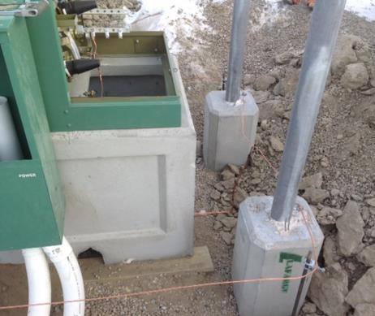
- Equipment identification
- Ground resistance measured.
- After inspection, the remaining excavation can be backfilled and compacted to within ±150 mm of final grade.
- No backfill will be allowed inside the transformer or cubicle bases.
- All conductive above ground facilities (i.e., metal guard posts or bollards, stand-alone CATV & TELUS pedestals, Third Party facilities, metering pedestals) within 3.0 m of a padmount transformer must be tied into the transformer’s ground grid.

Trench and Duct installation
Duct is always required in the following conditions:
- Within a lease site
- Under pavement, roads, parking lots and driveways
- Where landscaping restricts access to FortisAlberta facilities
- Where soil conditions dictate (example rocky areas with high water table)
Ducting should be installed to a depth of 1.2 m to 1.5 m for road crossings and normal mainline trench should be 1.0 m to 1.2 m from the final ground grade measured from the top of the conduit. Above the duct, 200 mm of sand to be added with red danger electrical tape on top. Any installation from a transformer/switch cubicle to a property line should include a 7 mm pull rope. An above ground marker must be placed at end of the conduit on property line.
Where cable pull tensions exceed 750 lbs., all bends and elbows shall be concrete encased with a minimum of 76 mm (3 inches) throughout the bending radius of the duct. Ducts encased in concrete shall be separated from each other by at least 25 mm of concrete. The concrete mixture shall have a compressive strength of 17.2 MPA (2500 psi).
The minimum duct size for use in primary cable installations shall be 102 mm (4 inches). Only Rigid PVC duct shall be used for elbows (no DB2 is allowed).
90° elbow ducts are to be installed under the equipment (i.e., transformers, pull box, switching cubicles), straight-up, cut-off at 100 mm (4 inches) above the bottom of the base, and install a bell at the end of the duct, where practical. Provisions should be provided to protect the duct upon the installation of the cable when entering/exiting the duct system.
When trenching towards a FortisAlberta asset, maintain the following separations (FortisAlberta will trench the rest of the way):
- Switching Cubicle: 3.0 m
- Riser Pole: 3.0 m
- Edge of utility right-of-way: 1.0 m
Primary duct/cable shall not be placed under buildings.
See Annex C for further details on conduit systems.

Guard Posts (Bollards)
The requirements for guard posts, including the necessary location and installations, must be confirmed with FortisAlberta prior to construction.
The guard post must be supplied by the customer. Refer to 1302 Bill of Materials.
Guard posts (bollards) must be installed on all sides of a transformer or cubicle if it is in an area exposed to vehicle traffic and is at risk of incurring damage from a vehicle. To avoid possible damage to the ground grid the guard posts should be installed before or at the same time as the ground grid. See drawing and materials 1302 for guard post positioning.
Guard posts must be bonded to the ground grid using #4 Cu for single phase or switching cubicles and #2/0 Cu for three phase installations.
If there is a secondary pedestal attached to the equipment/transformer pad, the guard post & ground grid should be extended in such a way as to protect the peripheral equipment also.
Post encasement is to be compacted all around with suitable back fill or gravel.

Crossing/Proximity to 3rd Party Right-Of-Ways, High-Pressure Pipelines and Power Lines
The customer is required to obtain the necessary permissions to enter upon, cross over, or construct under any 3rd party right-of-way, high-pressure pipelines, power lines, etc. for the installation of the underground electrical facilities. They are also responsible for the preparation and submission of the plans to the owners and/or proper authorities, and for any extra costs, work, damage claims and/or insurance costs related to meeting all conditions for any of the above-mentioned crossings. During the inspection, the customer’s consultant shall provide FortisAlberta with one copy of the customer’s crossing agreement (i.e., under the customer’s name) with the 3rd party company (i.e., pipeline, transmission, etc.).

Crossing/Proximity to Railways
If the customer owns, operates, and maintains the railway, they are responsible for casing a pipe installation under the rails in accordance with all applicable codes, in which case the detailed design and as-built engineer-signed and stamped drawing for the installation under the tracks is still required. If an approval for the installation needs to be obtained from a 3rd party (Canadian Pacific or Canadian National Railway Company), FortisAlberta performs the installation under the tracks at the expense of the customer.

Easements and Utility Right of Way
Every facility on customer property that serves two or more customer properties must be protected either by easements or a Utility-Right-of-Way. The necessity for easement and Utility Right of ways will be at the discretion of the FortisAlberta designer.

Environmental Considerations
The customer is required to comply with all federal, provincial, and municipal legislation, regulations, acts and bylaws, as applicable. The following are commonly encountered requirements that may impact the project but are not all inclusive.
The customer may be required to obtain the necessary approvals under Alberta’s Water Act or the federal Fisheries Act prior to the installation of the underground electrical facilities. A Water Act approval is required before undertaking a construction activity in a water body or before diverting water from a water body (water bodies include but are not limited to; lakes, ponds, rivers, creeks, seasonal drainages, and wetlands). A Fisheries Act approval is required for any work or activity that results in the harmful alteration, disruption or destruction of fish habitat or permits the deposit of a deleterious substance, one having a harmful effect, into any water frequented by fish. The final reclamation of the excavations impacting a water body must adhere to the conditions in the approval. Deficiencies identified during the final inspection will be rectified by the customer at the customer’s expense. During the inspection, the customer or customer’s consultant will provide FortisAlberta with one copy of the approval document.
The customer may be required to obtain the necessary clearance under the Alberta Historical Resources Act. A Historical Resources Act clearance is required on identified lands that contain or are believed to contain historic resources, including archaeological and paleontological sites, Aboriginal traditional use sites of a historic resource nature, and historic structures. A list of known Historical Resources is available on the Alberta Culture website. During the inspection, the customer or customer’s consultant will provide FortisAlberta with one copy of the approval document.
The customer should also minimize potential adverse effects to wildlife and habitats that may result from the installation of the underground electrical facility. Customers may be required to adhere to the Species at Risk Act or Migratory Birds Convention Act based on the presence of sensitive species or habitats.

Material Standards and Specification

General Requirements
The customer is responsible for supplying all materials required for meeting the minimum FortisAlberta standards throughout the duration of the work; this includes the customer’s delegation to another party to carry out the completion of the work (design consultants, construction contractors, and sub-construction contractors). Furthermore, the customer is responsible for all material supplied, and for the safe storage of all material until it has been incorporated in the completed and accepted work by FortisAlberta. The customer will replace, at no cost to FortisAlberta, any material that has been damaged in transit, or has been damaged after delivery and prior to energization.
All materials used in the design and installation of the underground electrical system will be new and from a manufacturer stated in the accepted list of suppliers provided in sections 8.2 through 8.5 (below) of this publication. If other than accepted materials are incorporated in the work, all such materials will be removed and replaced with accepted materials. This replacement will be completed at the customer’s expense, and to the satisfaction of the FortisAlberta field representative, prior to energization.
The accepted suppliers and catalogue numbers listed in the following material sub clauses have been previously evaluated by and/or supplied to FortisAlberta. Any other materials and/or suppliers not listed will not be accepted without prior acceptance from FortisAlberta. Suppliers or manufacturers who want their products to be considered can submit samples and full technical information to FortisAlberta for evaluation.

Pre-Cast Concrete
Pre-cast concrete bases are used for mounting single and three phase pad-mount transformers, solid dielectric switchgear, and live front switching cubicles as shown in Table 3. Drawings of the bases are provided with the corresponding links in Table 3.

Table 3 – Bases and Guard Posts
Description | Approved Suppliers | FortisAlberta Drawing No.
Pre-cast Concrete Base for Single Phase Transformer up to 167 kVA | D&M Concrete  Eagle Builders  H.O. Concrete  Knelsen Precast  LaFarge  Pretech | 755-0505
Pre-cast Concrete Base for Three Phase Transformer from 75 kVA and up to 500 kVA | D&M Concrete  Eagle Builders  Knelsen Precast  LaFarge  Proform Concrete  Westcon Precast | 755-0507
Pre-Cast Concrete Base for Three Phase Transformer from 750 kVA and up to 3000 kVA | D&M Concrete  Eagle Builders  Knelsen Precast  LaFarge  Westcon Precast | 755-0512
Pre-Cast Concrete Base for Three Phase Transformer from 1000 kVA and up to 20000 kVA | Lafarge | 755-0516
Pre-Cast Concrete Base for Three Phase 2-Way Padmount MVI | Proform | 755-0570
Pre-Cast Concrete Base for Three Phase 4-Way Padmount MVI and Three Phase Switching Cubicle | Knelsen Precast  LaFarge | 755-0557
Guard Post and base with grounding stud | Knelsen Precast  LaFarge | 1302

Grounding Materials
The materials that can be used when installing the grounding and ground grids around padmount transformers, switching cubicles, secondary junction boxes and pedestals, streetlights, and pull boxes can be found in Section 15.5 of the FortisAlberta’s Service and Metering Guide as presented in Annex E.

Conduit Materials
The materials that can be used when installing the conduit (ducts) can be found in Annex D. Additional information on Conduit Materials is available in the FortisAlberta Service and Metering Guide, Section 15.4.

Guard Post Materials
The guard posts (bollards) in Table 3 are built to protect the transformer. They must be built and positioned according to the material in Table 3 and as shown in the (1302) drawings.

Inspection and Testing

General Requirements
FortisAlberta will have the final say regarding any installation/construction issues, discrepancies, and/or problems. An inspection will take place after the customer completes their installation, and before any backfilling takes place.

Scheduling Inspections
The customer is to call 310-WIRE (9473) five (5) working days prior to the backfill of any underground facilities. FortisAlberta field representatives work eight (8) hour days between the hours of 7:30 a.m. through 4:00 p.m. (including travel time to site), Monday through Friday. It is the contractor’s responsibility to coordinate all inspections accordingly. Any requests outside these hours will be at the discretion of the FortisAlberta field representative and at the contractor’s cost. All notifications after 4:00 p.m. on any given working day will be considered as occurring the next business day.
If the customer proceeds without inspection prior to backfilling, they will be responsible for any additional cost and/or delays incurred to rectify any problems that may develop (e.g., hydrovac costs).

Warranty
The customer must provide an eighteen-month warranty on all facilities, including any that may be leaning or not to grade due to improper installation or tampering. This warranty should be effective following the service energization.
If there are any deficiencies during the warranty period, the customer shall remedy the deficiency, commence a remedy on the deficiency, or come to an agreement with FortisAlberta on the remedial action necessary within thirty (30) days of notice from FortisAlberta.

Revision History (Informative)
Version | Comments | Date
1 | Initial | 2009
2 | Added Switch Cubicle and MVI base. Concrete poured in bends. | May-13
3 | Added Environmental Considerations. | Aug-15
3 | Added base for larger transformers 755-0514. | Aug-15
3 | Revised 1302 drawings. | Aug-15
4 | Site grading requirements added. | Oct-15
4 | Moved the warranty information to 7.3. | Oct-15
4 | Depth of concrete required on elbows 5.3. | Oct-15
4 | No electrical cables under buildings 5.3. | Oct-15
4 | Foundation support requirement 5.1. | Oct-15
4 | Bill of Material, changes to pad based on voltage as well as capacity (MVA), 6.2. Annex A Bill of Material. | Oct-15
4.1 | New complex AFC example in annex. | Mar-16
4.1 | 2.4 and annex: application for before curb and gutter installations. | Mar-16
4.1 | How-to brochure as annex. | Mar-16
4.1 | 2.6 clarification of grading requirements | Mar-16
4.1 | 7.3 warranty clarification | Mar-16
4.2 | 2.4 cable pulling clarification | Sep-16
4.3 | General & Applicability section clarification | Aug-18
4.3 | 5.1 Clarification on minimum separation requirements | Aug-18
4.3 | 5.3 Updates on duct requirements | Aug-18
4.3 | Other minor changes for clarification | Aug-18
4.4 | Section 6.2 Changed supplier name from Armtec to Knelsen. 755-0514 discontinued and removed | Oct-19
5.0 | General rearrangement and formatting. New cover page. | Nov-20
5.0 | Section 1.1, added texts to follow CIPGD process for efficient installation of facilities. | Nov-20
5.0 | Section 4, added “off-site work” and “UEDS” in the glossary. | Nov-20
5.0 | Section 6.3, added text regarding ground testing. | Nov-20
5.0 | Section 7.4 added stipulation to concrete encase sweeps and elbows where pulling tension exceeds 750 lbs. Added reference to Annex C of the SMG for detail on Duct Systems | Nov-20
5.0 | Section 8.2 changed the description from Molded Vacuum Switch (MVI) to Solid Dielectric Switch also modified the description for switching cubicles stating that they are live front switching cubicles. Change Table number from 2 to 3 and any reference to it in this section. Updated manufacture information added Wescon Precast to item 755-0507 and 755-0512. Added a new item no. 755-0516 to replace 755-0514. | Nov-20
5.0 | Section 8.3 and 8.4, provided references to SMG sections and provided in Annex D and E. | Nov-20
5.0 | Annex A, Version History Updated | Nov-20
5.0 | Annex B replaced 755-0514 with 755-0516; modified Annex to Forms and References; all references are now in Word format. Removed “How-to-Guide” reference document. Added Structure 1226. | Nov-20
5.0 | Annex C, included SMG, Annex C, Conduit Systems | Nov-20
5.0 | Annex D, included SMG, Section 15.4, Conduit materials | Nov-20
5.0 | Annex E, including SMG, Section 15.5, Grounding Materials | Nov-20
5.1 | Included 1226 (2/3) and 1315 (2/4) Structure Drawings in Annex B. | Dec-22
5.1 | Expanded Table 1 with additional details. | Dec-22
5.2 | Provided clarity on when to pour concrete on bends and elbows. Updated AFC prints and checklists. | Aug-23
5.2 | Updated Annex D, Conduit materials | Aug-23
5.3 | Re-attached various drawings with higher resolution | Oct-24
5.3 | Updated Annex D, Conduit materials | Oct-24
5.4 | Updated Annex D, Conduit materials | Dec-24
5.5 | Section 6.1 - Updates in Utility Right of Way requirements  Updated Annex D, Conduit materials  Annex B, Structure and BOM updates  Annex C, Duct Systems | Sept-25

Forms and Reference (Informative)
- Structure Drawing 1302 (2 pages and Bill of Materials), Service Guard Post
- SMG 7.1, Commercial Services, Location of Padmount Transformers
- Structure Drawing 1315, Three Phase Padmount Transformer General Arrangement
- Structure 1315, Three Phase Transformer, Civil and Grounding Bill of Materials
- Structure Drawing 1226, Single Phase Pad Mount Transformer, General Arrangement
- Structure 1526, Single Phase Transformer, Civil and Grounding Bill of Materials
- Drawing 755-0505, Pre-Cast Concrete Base for 1-Phase Transformer up to 167 kVA
- Drawing 755-0507, Pre-Cast Concrete Base for 3-Phase Transformer up to 500 kVA
- Drawing 755-0512, Pre-Cast Concrete Base for 3-Phase Transformer, 750 to 3000 kVA
- Drawing 755-0516, Pre-Cast Concrete Base for 3-Phase Transformer, 1000 to 20000 kVA
- Drawing 755-0557, Pre-Cast Concrete Base for 3-Phase, Switching Cubicle & 4-Way MVI
- Drawing 755-0570, Pre-Cast Concrete Base for 3-Phase, 2-Way MVI
- CIPGD Process Flowchart
- Ground Grid Test Report
- Example and Template of AFC for Simple Services
- Example of AFC for Complex Services
- Application to Install Underground Electrical Distribution Systems Without Curbs and Gutters

1. Structure Drawing 1302 (2 pages and Bill of Materials), Service Guard Post

2. SMG 7.1, Commercial Services, Location of Padmount Transformers
3. Structure Drawing 1315, Three Phase Padmount Transformer General Arrangement
4. Structure 1315, Three Phase Transformer, Civil and Grounding Bill of Materials
5. Structure Drawing 1226, Single Phase Pad Mount Transformer, General Arrangement
6. Structure 1526, Single Phase Transformer, Civil and Grounding Bill of Materials

7. Drawing 755-0505, Pre-Cast Concrete Base for 1-Phase Transformer up to 167 kVA
8. Drawing 755-0507, Pre-Cast Concrete Base for 3-Phase Transformer up to 500 kVA
9. Drawing 755-0512, Pre-Cast Concrete Base for 3-Phase Transformer, 750 to 3000 kVA
10. Drawing 755-0516, Pre-Cast Concrete Base for 3-Ph Transformer, 1000 to 20000 kVA
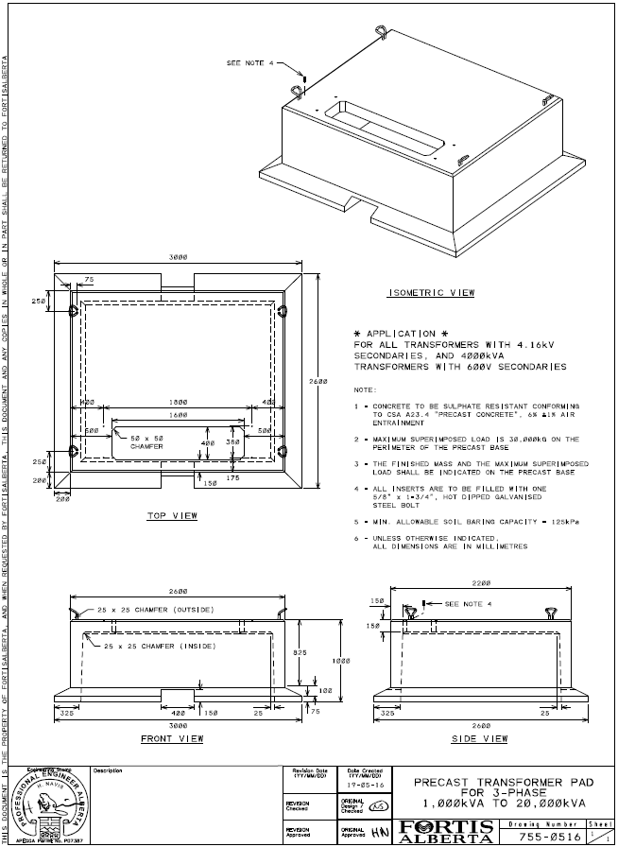
11. Drawing 755-0557, Pre-Cast Concrete Base for 3-Ph Switching Cubicle & 4-Way MVI
12. Drawing 755-0570, Pre-Cast Concrete Base for 3-Phase, 2-Way MVI
13. Customer Installed Pre-cast Base, Grounding, and Ducting (CIPGD) Process
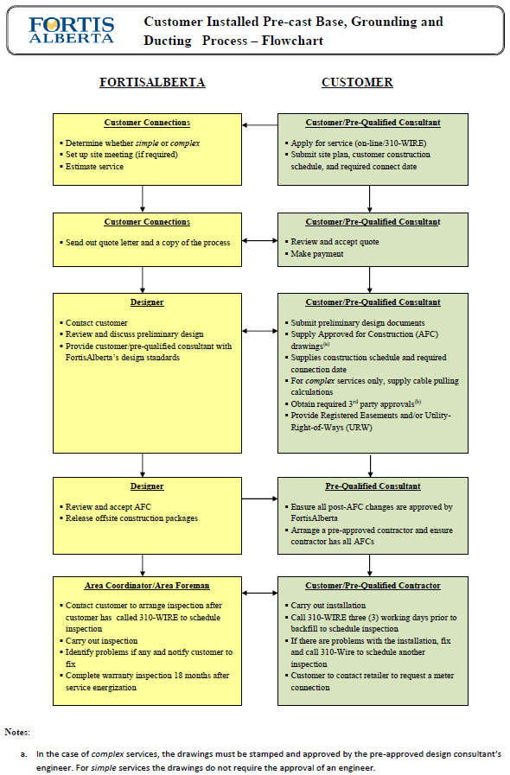
14. Ground Grid Test Report
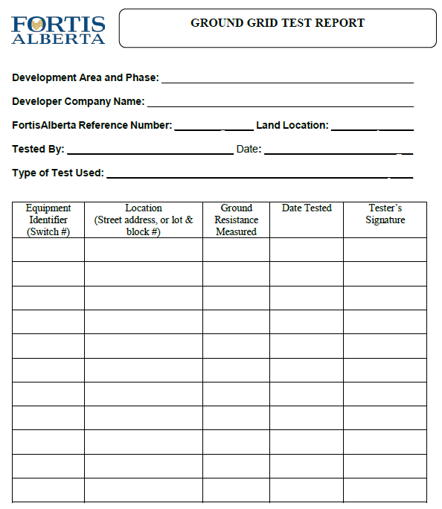
15. Example and Template of AFC for Simple Services
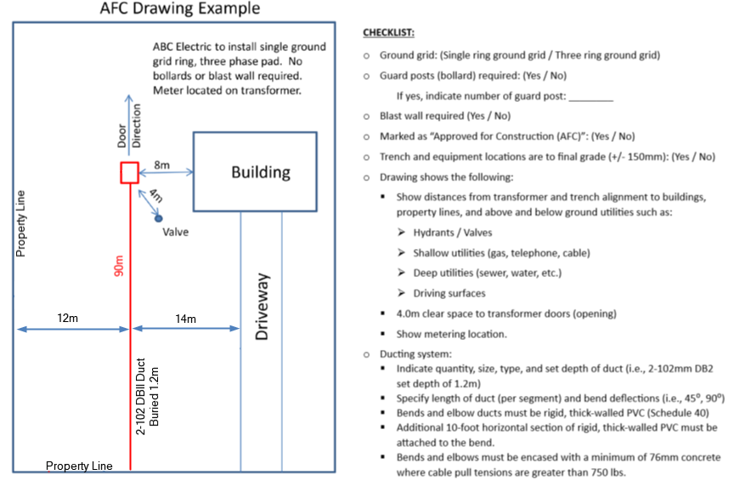

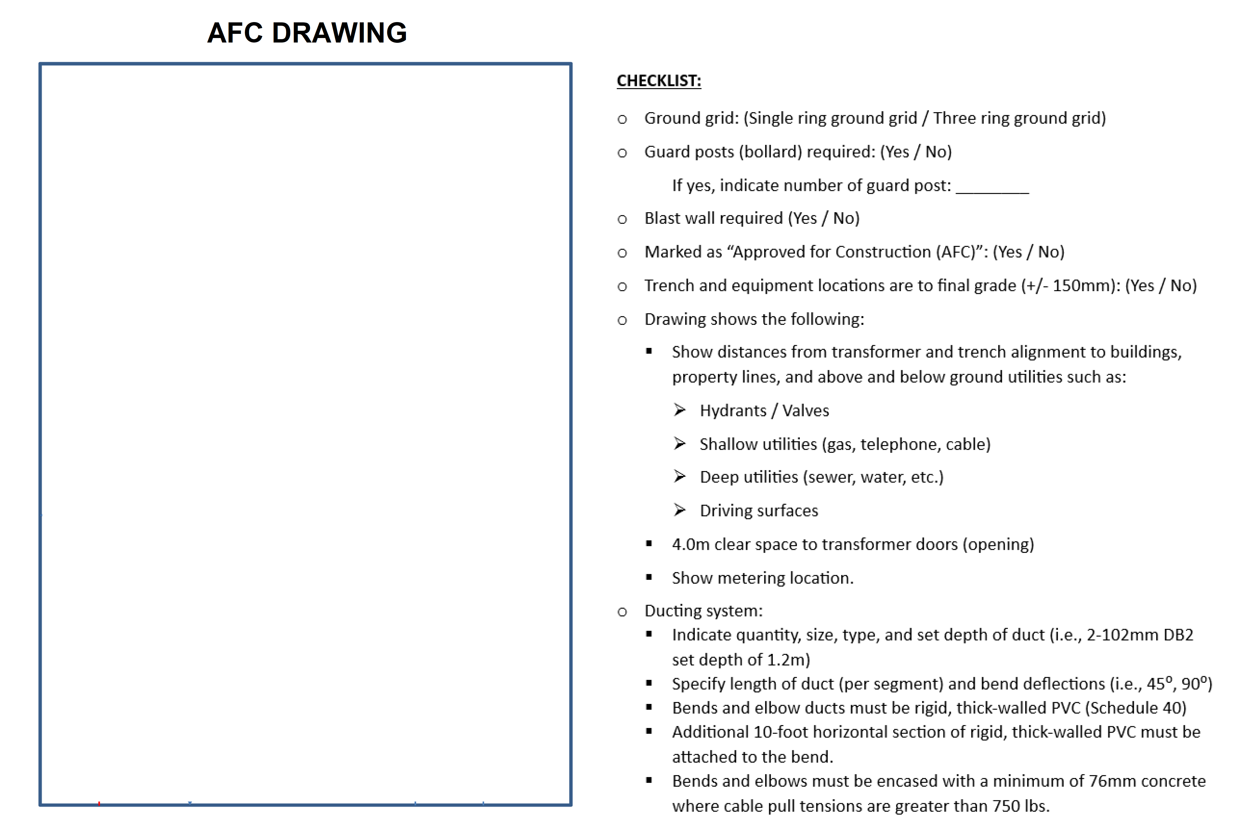
16. Example of AFC for Complex Services

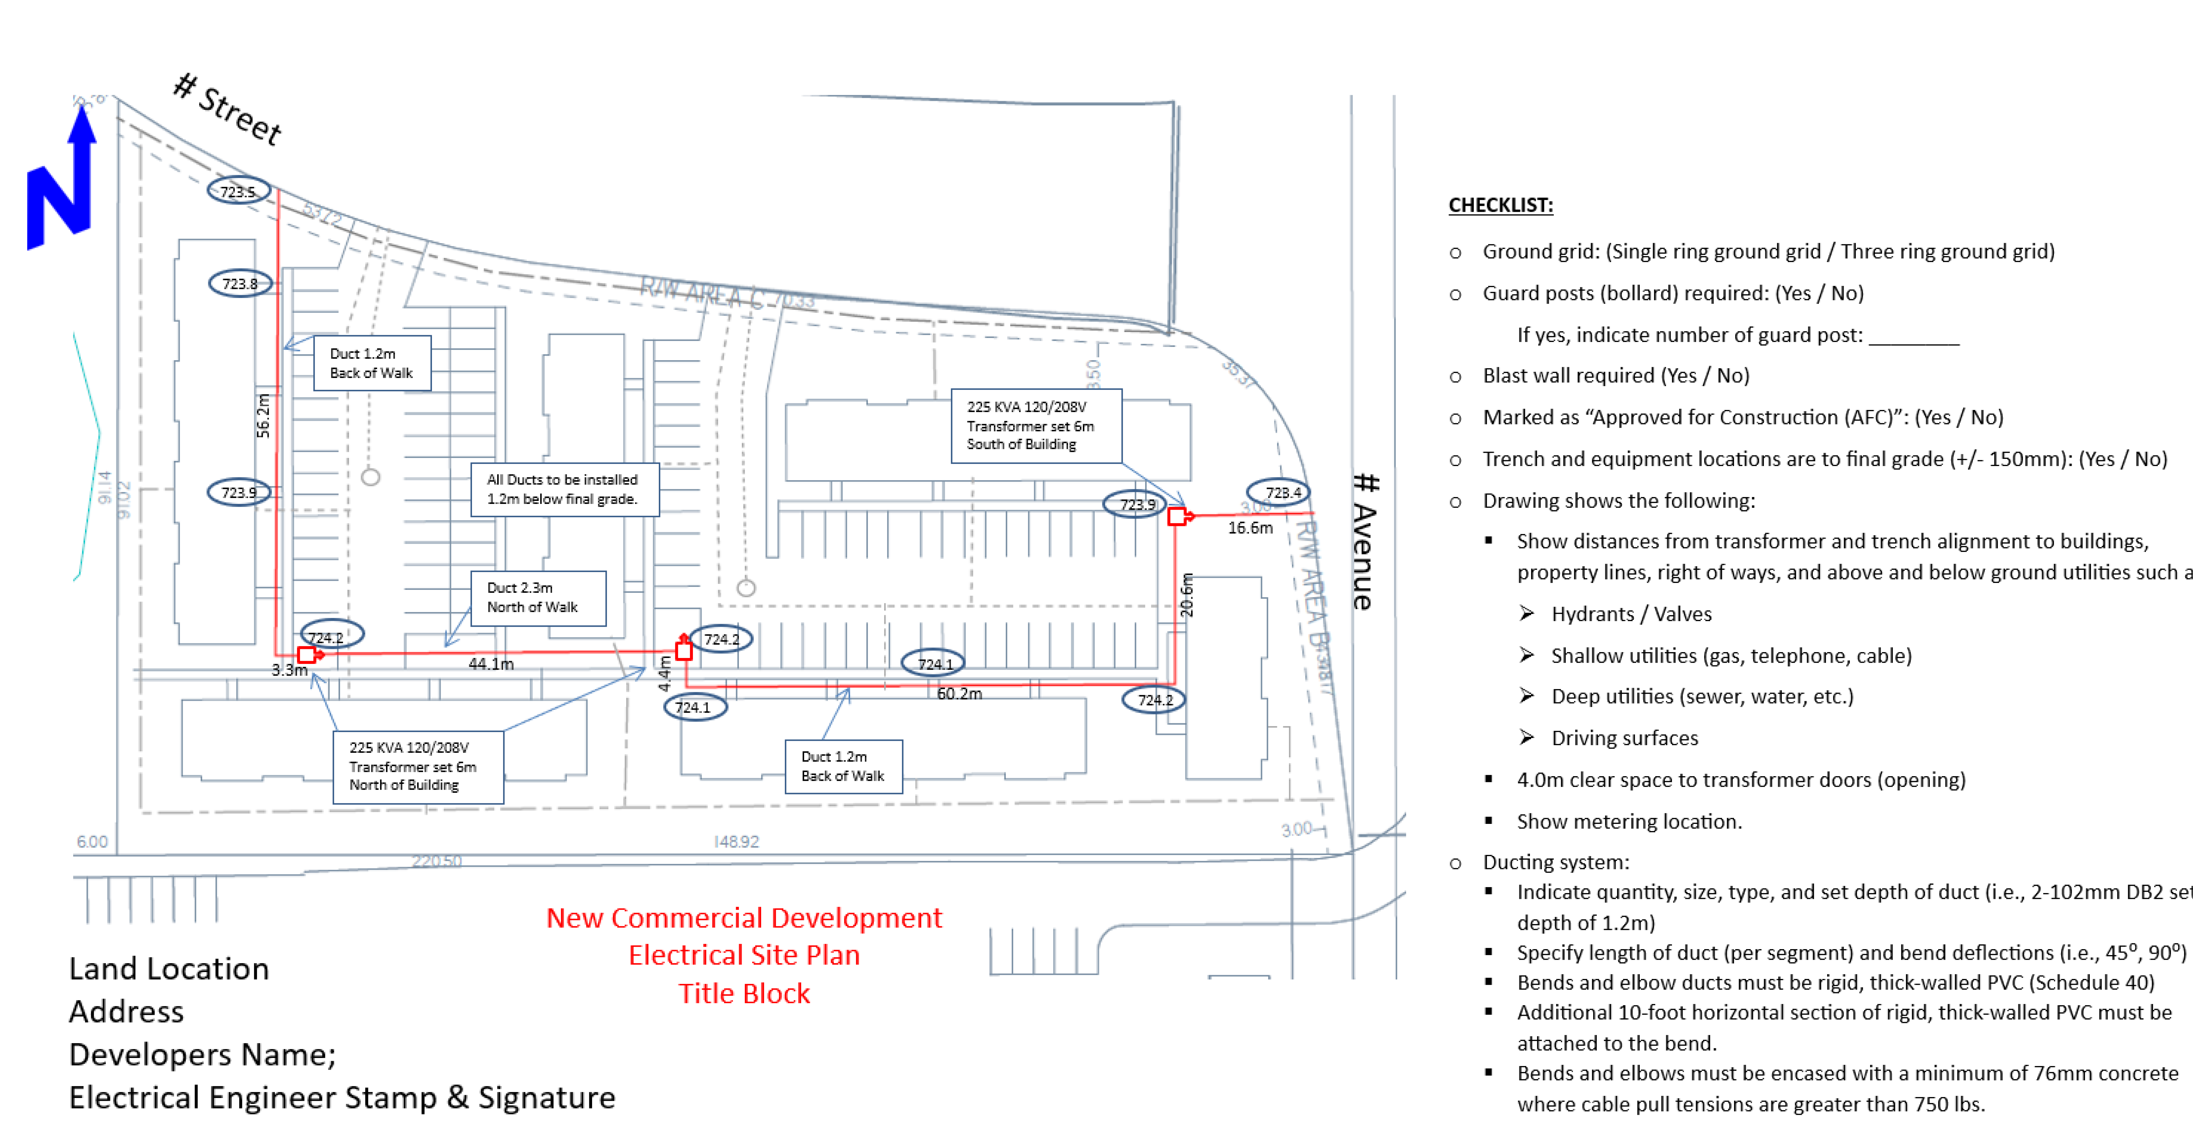

- Application to Install Underground Electrical Distribution Systems Without Curbs and Gutters

APPLICATION TO INSTALL UNDERGROUND ELECTRICAL DISTRIBUTION FACILITIES WITHOUT CURBS AND GUTTERS



Development Area and Phase:
Developer:
FortisAlberta Reference Number: Date:

In pursuant to the Underground Electrical Distribution Services Agreement and in accordance with the Underground Electrical Distribution Systems (UEDS) Manuals, Part 1 to 5, (the “Developer”) and of the firm (the “Consulting Engineer) requests FortisAlberta’s Acceptance of the proposed development or part of the development area being applied for (the “Work area without curbs and gutters”), to proceed with the installation of underground distribution facilities without curbs and gutters due to the following reasons:

REASONS:
______________________________________________________________________________________________________________________________________________________________________________________________________________________________

The Developer and the Consulting Engineer agrees and commits:

(The following shall be submitted and/or completed along with this request and prior to start of construction on the “Work area without curbs and gutters”):
- To provide a Facility Map of the location of the “Work area without curbs and gutters.”
- To obtain a written approval from the governing body (i.e., Municipality), as applicable, in respect to the development area, to proceed with the installation of underground electric distribution facilities without curbs and gutters.
- To provide a plan showing the proposed final ground line elevation along the trench alignment and at all equipment locations.
- All trench and grade stakes shall be installed every 10 meters along the proposed alignment and at equipment locations. These stakes need to be in place and preserved for AC inspection.

(The following shall be performed during the construction of the Work within the “Work area without curbs and gutters”):
- To arrange with the FortisAlberta Crew Lead/Unit Price Area Coordinator to perform inspections prior to back fill of the trench. (FortisAlberta Crew Lead/Unit Price Area Coordinator requires five (5) day notice prior to the actual performance of the Work).
- Record/capture the elevation at the top of the duct/cable and at the top of equipment pads after installation. This information should be contained in the provision of a grading as-built plan.

(The following shall be completed and submitted upon completion of the Work within the “Work area without curbs and gutters” and will form part of the requirements prior to FortisAlberta’s Acceptance and issuance of Functional Completion Certificate):
- To provide a grading as-built plan showing the actual ground elevation after backfilling and the recorded elevations at the top of the installed duct/cable along the trench alignment and at the top of all equipment pad locations.
Note: The actual ground elevation after backfilling shall be within +/- 150mm (6 inches) of the proposed final grade elevation. Upon submission of a grading as-built plan, no other excavation work (i.e., cutting, fill) be made along the installed facilities without a written consent of the FortisAlberta Crew Lead/Unit Price Area Coordinator.

FortisAlberta reserves the right to have the Developer hydrovac at locations as deemed appropriate and witnessed by the FortisAlberta Crew Lead/Unit Price Area Coordinator to confirm that the actual depths of the ducts/cables are within 1.0m to 1.2m for standard trench and 1.2m to 1.5m for road crossings, from final ground line elevation.

All deficiencies and non-compliances of the required work are the responsibility of the Developer.

Developer Representative: Consulting Engineer:

Signature: ______________________ Signature: ____________________

Name and Title: _____________________ Name and Title: _________________________

Duct Systems (Informative)
(This content is copied from the Service and Metering Guide Rev. 6.0, Annex C. In the event of any discrepancies, the most recent version of the Service and Metering Guide Version shall take precedence.)

Duct Systems

Pre-Installation Preparation:
- Approval - All proposed cable routing and duct work for primary (high-voltage) cable installations on behalf of FortisAlberta are subject to written approval by FortisAlberta prior to construction.
- Orientation - An on-site orientation is required for the customer or their contractor to review routing plans and discuss the specifics of trenching activities. This includes addressing any safety hazards, concerns, coordination, or shared civil work between the customer and FortisAlberta when installing electrical facilities on roads and/or Utility Right-of-Way, ensuring compliance with all safety requirements.
- Safety Procedure - Contact Utility Safety Partners (formerly Alberta One-Call) before starting work.
- Property Rights - Underground service lines shall be kept a minimum of 1.0 m (3.3 ft) from the edge of the property line.
As a customer, you are not permitted to perform excavation work in the Utility Right-of-Way without approval from the local road authority, however, you are required to complete all trenching on your property.

Trenching and Excavation:
  - Route - Ensure the trench takes the most direct route to the meter base location.
  - Depth – Under standard conditions, the top of the duct shall be 1,000 mm (33 in) to 1,200 mm (48 in) below finished grade for normal trenching, and 1,200 mm (48 in) to 1,500 mm (60 in) for road crossings. Trench depths exceeding these values require approval from FortisAlberta.
  - Facility Location - Some tasks may necessitate work above energized primary (high-voltage) or secondary (low voltage) utility owned cables, potentially involving crossing or trenching over these cables. Mechanical excavation is permissible up to 3.0 m (10 ft) from the energized facilities, such as switching cubicles or riser poles. Typically, FortisAlberta will handle the remainder of the trenching process. However, under specific conditions, FortisAlberta may permit the customer or contractor to complete the work.
Before determining the boundaries of mechanical excavation, it is imperative to locate the facilities accurately using hydro excavation or hand digging methods.
  - Clearance – Contractors working on behalf of the customer are prohibited from trenching within the following distances without prior consultation with FortisAlberta:
  - 1.0 m (3.3 ft) radius of any FortisAlberta wood pole
  - 2.5 m (8.2 ft) from the point of entry of an anchor or guy into the ground
  - 3.0 m (10 ft) from an existing energized padmount transformer, switching cubical, pedestal, or energized cable.
To ensure the safety and integrity of FortisAlberta’s infrastructure, it is mandatory to locate these facilities accurately before determining the limits of mechanical excavation. This can be achieved through hydro excavating or hand digging methods.
Furthermore, any trenching activities that may encroach upon the specified clearance parameters require an on-site meeting with FortisAlberta’s personnel (FortisAlberta Power line Technician) to discuss and assess the situation thoroughly. See Section C.1.1 regarding Orientation.

Cable or Duct Installation:
  - Bedding - Service cable shall be set on undisturbed soil that is free from rocks, debris, and sudden grade changes. If large lumps of clay and soil have hardened due to drying or freezing, and when a backhoe has been used for electrical service installation, a 100 mm (4 in) layer of sand shall be placed below the cable.
For duct installation in native soil, the duct can be set at the bottom of the trench without additional bedding.
When installing duct in locations with rock or shale, excavate 76 mm (3 in) below the desired depth and bring the trench back to grade with sand or fill material. This will provide the duct with a uniform bedding surface.
- Sand Layer - Place a 200 mm (8 in) layer of sand above the cable or duct.
- Marker tape - Install marker tape above the sand bed.
- Marker Ball - Install a color-coded Red (Electrical) 4-inch marker ball tuned to 196.8 kHz at splices, buried service drops or were crossing underground facilities.

Backhoe Trenching and Backfilling:
  - Trench Bottom - Should provide a continuous firm and uniform support for the duct bank construction. Care should be taken to avoid lumps, ridges, depressions, organic material (tree roots) and stones causing “point” contact or uneven bearing.
  - Unstable Soils - Conduct tests to establish the soil strength in marsh or swamp areas. It may be necessary in these conditions to dig deeper and refill with crushed stone or gravel, or to employ mats, timbers or concrete base.
  - Backfill Material - Can be the material trenched with a mechanical trencher if the inspector deems it suitable. Soil with high thermal resistivity that contains large amounts of organic, peat, black loam, sod, hardened clay, stones, straw, snow, or frozen material will not be acceptable. All backfill material is subject to the inspectors’ approval. Sand or clean backfill material shall be substituted if the native backfill is unusable.
  - Backfill Compaction - Compact backfill in uniform lifts not exceeding 305 mm (12”) to specified densities 95 per cent of (SPD) for silty and clay soils, 70 per cent relative density for sands and gravels- ASTM D1556 [B15].

Direct Buried Duct Bank Installation:
  - See Section C.1.3 duct installation and C1.4 for backhoe trenching and back filling details along with the following additions:
  - Placement of Duct - After the first tier of duct is installed, backfill and compact as outlined below. If wood steaks are employed for spacing, remove them as the backfill is placed and tamped. Then begin the next tier.
  - Initial Backfilling - Install backfill along the side, between and at the top of the duct. Use a hand tamper only to tamp firmly.
Backfill over the duct to the required thickness (see Final Backfilling) and tamp firmly, using a hand tamper.
All “initial backfilling” material shall pass the following gradation:
Table C1 – Aggregate gradation table.
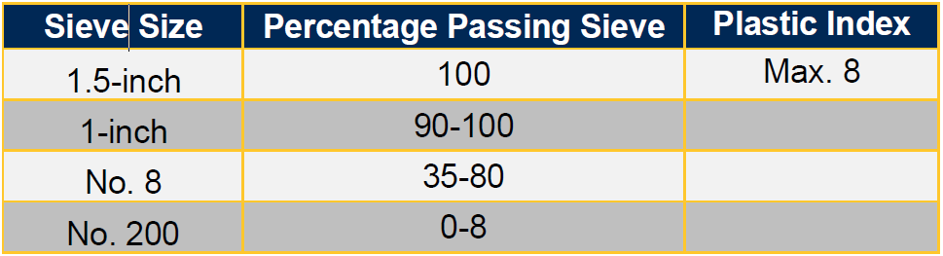
  - Final Backfilling - When the last tier is placed, hand-place the backfill to 200 mm (8 in) over the cable or duct with soil that does not contain stone larger than 9.5 mm (3/8 in).
From this point, backfill may be completed by hand or by pneumatic tamping in layers from 200 mm (8 in) to 305 mm (12 in).
The backfill material shall be placed in a manner that will not damage the duct, its structure, or allow future settling of the trench or substructure.
When placing backfill by machine, avoid the use of large rocks until a protective layer (minimum of 305 mm (12 in)) is established.
Backfill thickness between duct is usually between 51 mm (2 in) to 71 mm (8 in) see Figure C-1.
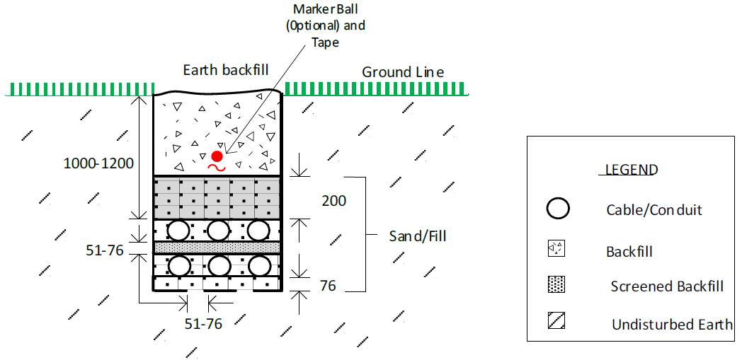
Figure C-1 - Typical direct buried electrical duct bank layout with sand fill.
NOTE: for direct buried duct, spacers should not be used with DB2 or rigid PVC. Spacers will only provide “point” support instead of the continuous bed that is required. Use of spacers may result in damage to the conduit when using sand fill.

Safety and Compliance:
  - Energized Facilities - Consult with FortisAlberta for trenching near energized cables. Follow Utility Safety Partners procedures before starting work. See Section C.1.1, Orientation.
  - Temporary Covering - Exposed energized cables cannot be left unattended. If the excavation is narrow or small, the primary cable shall be covered with soil bags or some other suitable temporary method. Contact FortisAlberta for more details.
Under no circumstances shall energized primary cables be moved or handled in any way.

Documentation and Record Keeping:
  - Record Keeping: Maintain detailed records of the installation process, approvals, inspections and as-built drawings.
  - As-Built Drawings: Prepare and submit as-built drawings showing the actual location, depth and details of the cable or duct installation, including pull direction and final pull tensions, for future reference and maintenance.
By following this duct installation procedure, you can ensure a compliant and safe installation that meets the requirements of FortisAlberta and industry standards. Always consult with FortisAlberta and the local authority having jurisdiction to ensure compliance with all regulations and guidelines.

Service Ducts
- FortisAlberta reserves the right of final approval for the location of facilities before granting construction approval.
  - It is recommended that permanent commercial services be in duct.
  - All service cables shall be enclosed in rigid PVC duct when crossing a paved surface, such as a driveway, laneway, or municipal right-of-way located outside private property.
  - Ducts shall be installed where primary cable is deemed inaccessible by FortisAlberta.
  - All ducts shall be equipped with bell collars to avoid damaging the cable.
  - The installation of primary service cables under buildings is not permitted.
  - The customer will provide all ducts (rigid PVC, DB2, HDPE or various trenchless race way duct approved by FortisAlberta), pull boxes and manholes required for installing the electrical services on the customer’s property.
  - The customer cannot install ducts into an energized manhole or handhole of a vault.
  - Duct sizes requirements for primary cables depend on cable size and number of cables to be installed in the duct. FortisAlberta offers two sizes 4-inch and 6-inch for duct systems.
  - When FortisAlberta ducts have been stubbed to the property line, customers shall first confirm that the exposed duct is the correct one and then connect their service entrance duct to the FortisAlberta’s supply duct, if provided. Contact 310 Wire (9473) to arrange for duct verification.
  - If pulling lengths exceed the maximum pulling tension of the cable, a pull box shall be installed.

Duct Bends
- All bends and elbows shall be made of ridged, thick-walled PVC (schedule 40), DB2 bends are not acceptable.
  - All bends and elbows that have a pull tension in excess of 3336 N (750 lb) shall be encased in a
- minimum of 76 mm (3 in) of concrete through the radius of the bend. Ducts encased in concrete shall be separated from each other by at least 25 mm (1 in) of concrete. The concrete mixture shall have a compressive strength of 17.2 MPA (2500 psi) minimum.
  - An additional 3.0 m (10 ft). horizontal section of rigid, thick-walled PVC shall be attached to the bend.
- Ducts containing primary cables shall be aligned directly underneath the high-voltage bushings of the transformer and centered within the base opening. Duct bends shall exit the earth at a 90-degree angle, be cut off at 100 mm (4 in) above the bottom of the base and have a bell end or collar installed to prevent damage to the cable.
- All spare ducts are to be identified (marked or labeled) and caped (taped or covered by some other suitable method) to prevent material falling into them.
- Ducts containing primary cables entering switching cubicles shall be clearly labeled to identify the equipment they service (e.g., transformers, switchgear etc.).

Rationale for Concrete-Encased Elbows and Joints:
  - Concrete encasement of elbows and joints serves as an additional safeguard in duct systems, particularly during cable pulling for new installations. There is a risk that cables or pull ropes may burn through the elbow, compromising the duct system's integrity. Encasing elbows and joints in concrete provides insurance against cable burn-through or conduit heaving or pulling apart during high-tension pulls (installation and removal).
  - In new construction, these issues can be mitigated through pull calculations or the use of lubrication to prevent cable damage due to high sidewall bearing pressures.
  - The primary advantage of concrete encasement becomes evident during future upgrades or repairs to the cable system. Over time, ducts may accumulate mud, sludge or debris, making cable removal challenging (tensions required to pull the cable out will easily exceed the calculated pull in tensions). When extracting the cable, the focus shifts from protecting it to ensuring the integrity of the conduit system. Concrete encasement adds an extra layer of protection, preventing excessive force from rupturing the conduit system while removing cables due to failure or capacity increases.

Conduit Materials (Normative)
(Some of the content herein is adapted from the Service and Metering Guide Rev. 6.0, Section 15.4. In the event of any discrepancies, the most recent version of the Service and Metering Guide Version shall take precedence.)
Conduit Materials
Description | Approved Suppliers | FortisAlberta Drawing No. or Cat. No.
PIPE, nominal size 2-inch, rigid PVC, belled end, per CSA Standard C22.2 No. 211.2 latest revision. | Any electrical distributor
PIPE, nominal size 4-inch, rigid PVC, belled end, per CSA Standard C22.2 No. 211.2 latest revision. | Any electrical distributor
PIPE, nominal size 4", PVC, Type DB2, 20' length belled end, Color: Red | IPEX | 008218
Pipe, corrugated, High Density Polyethylene, coloring shall be UV stable red, per CSA Standard C22.2 No. 327 latest revision,  This product can be used as an alternative to DB2 PVC.  (FortisAlberta item #632-2804) | Dura-Line
Adaptor, coupler, mechanical, 4-inch, for corrugated, to schedule 40 HDPE, PVE, or steel duct.  (FortisAlberta Item No. 632-3764) | Dura-Line
Adaptor, coupler, mechanical, 4-inch, for corrugated, to DB2 PVC duct.  (FortisAlberta Item No. 632-3774) | Dura-Line
Coupler, mechanical, 4-inch, for corrugated duct.  (FortisAlberta Item No. 632-3074) | Dura-Line
For use on road crossings:  PIPE, High density polyethylene 4-inch IPS SDR 11. Pipe coloring shall be UV stable red coloring or red with black striping are acceptable, per CSA Standard C22.2 No. 327 latest revision.  (FortisAlberta item # 632-3008)  Or  PIPE, trenchless raceway, 4-inch PVC, 20-foot (FortisAlberta item # 632-3015) | IPEX  Dura-Line  United Poly Systems  Polytubes
 | Carlon | BG440SP-020

Grounding Materials (Normative)
(This content is copied from the Service and Metering Guide, Annex C, Rev. 6.0. In the event of any discrepancies, the most recent version of the Service and Metering Guide Version shall take precedence.)
The following materials are required to install the ground grid around padmount transformers:
Description | Approved Suppliers | FortisAlberta Drawing No. or Cat. No.
#4 bare copper conductor, stranded  (FortisAlberta item # 531-0220) | Any electrical distributor
#2/0 bare copper conductor, stranded  (FortisAlberta item # 531-0202) | Any electrical distributor
For use on transformer grounding:  - Sectional ground rods, 3/4" x 4', tapered at both ends  (FortisAlberta item # 557-1421)  - Coupling for sectional ground rods  (FortisAlberta item # 557-1525) |  | SKT 1499
 | Nvent/Erico  Southern Grounding  Axis | 613440  C344  GR3404CB
 | Nvent/Erico  Axis | CC34  GRCC34CU-CUL-COUPLINGS
Ground rod connector for use with sectional ground rods  (FortisAlberta item # 557-1311) |  | SKT. 1499
 | Axis | GRC3426
Ground connector for padmount transformers (FortisAlberta item # 553-0611) | Burndy/Hubbell | EQC26CG14
 | H-J International | AS1358-001
 | Penn-Union | HGSE020-SBHL1
Connector, parallel grove, compression type, copper, for #4 copper str. conductor  (FortisAlberta item # 553-0152) | Burndy/Hubbell | YC4C4
 | Homac | CC44
 | Ilsco | ULT-5
 | Kearney/Eaton | 302-82
Connector, parallel grove, compression type, copper, for #2/0 copper str. conductor  (FortisAlberta item # 553-0155) | Burndy/Hubbell | YGHC26C26
 | Ilsco | ELT-2
 | Thomas and Betts | CTP2020

